**PEER REVIEWS**

**GDP2-Sec3-01(Kushal Katari, Akhil Mallepally)**

<https://github.com/akhilmallepally/bearcat-events>

<https://github.com/kushalkatari/Proposal5B-BearcatE/blob/main/Proposal.md>

<https://bearcat-events.herokuapp.com/>

**Jaya kumar Saga**:

1. Check for auth0 authentication
   1. **Auth0 is not implemented completely**
   2. **Able to route to page to allow the app to use the GitHub**
   3. **Not able to navigate back to the application homepage**

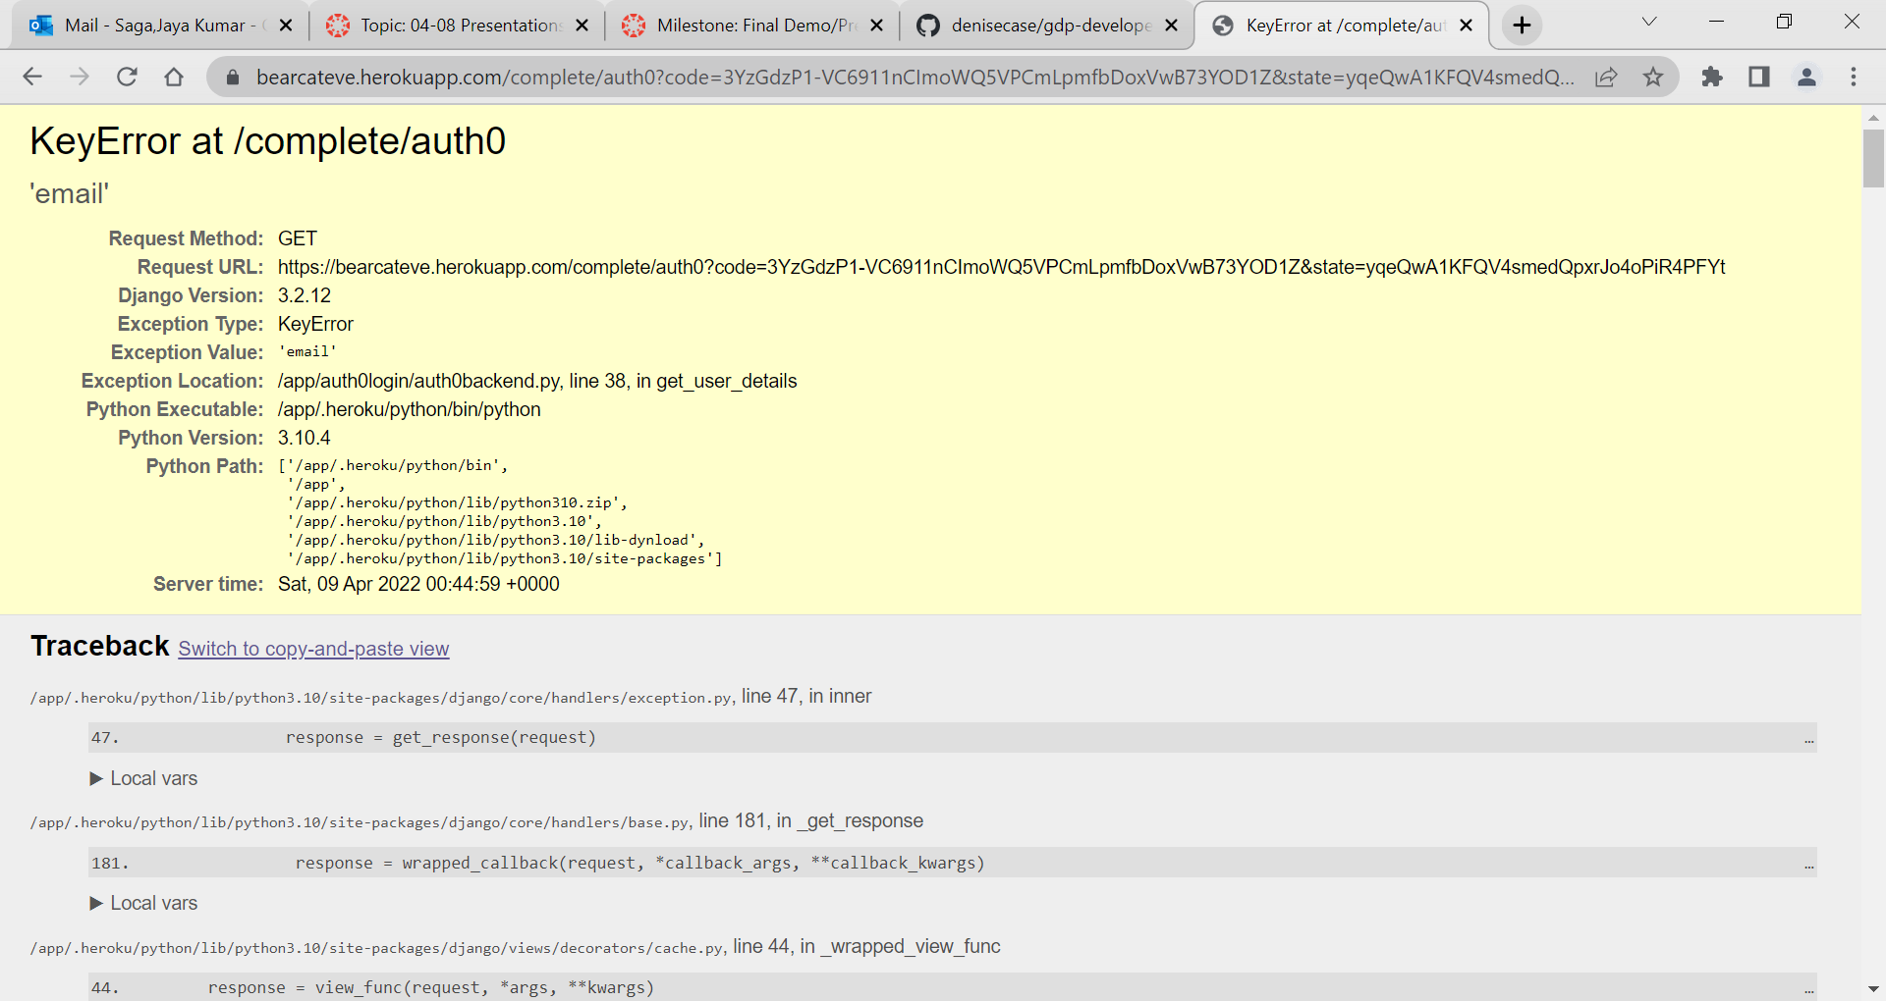

1. Check for the opening page
   1. **Opening page looks good and lighthouse report is good**

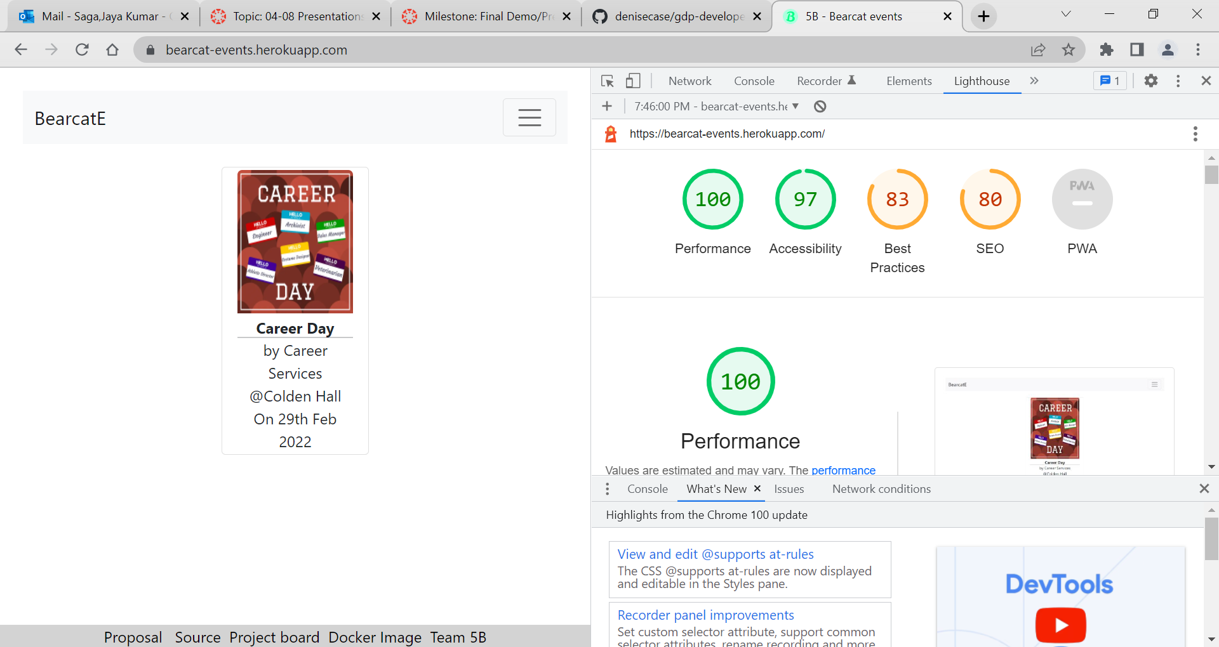

1. Check for issues
   1. **Some links in the footer are missing(Swagger api)**

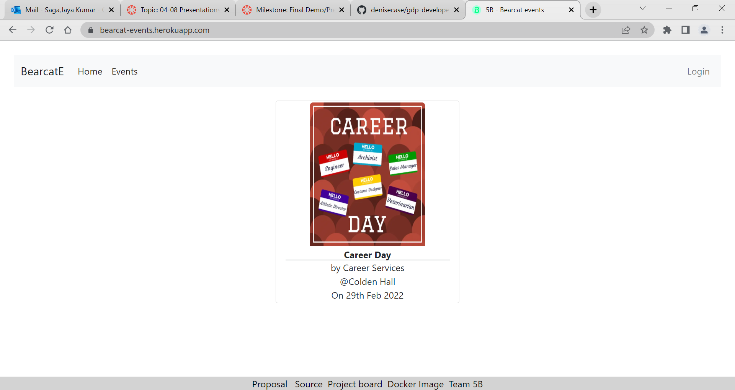

1. Check for Unit Tests
   1. **Done**

**Rasagna Reddy Banda**:

1. Check if the app is successfully deployed to Heroku

**Yes app is deployed on Heroku**

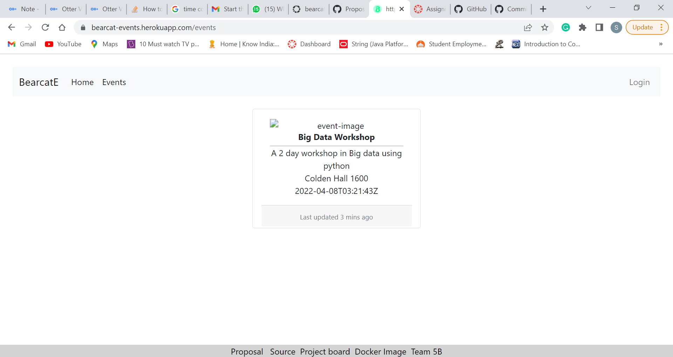

1. Check for the CRUD operations. **Can’t find the options to do curd operations**
2. Check for milestones

* **Added actions, documents, created jango tests**
* **Doesn’t have GitHub releases for beta and final version**

1. Check for the second page

**Seeing only one event in the list view**.



**Keerthi Muli**:

 9. Check if they have codacy:

**Excellent! I can see codacy in action.**

<https://app.codacy.com/gh/akhilmallepally/bearcat-events/dashboard?utm_source=github.com&utm_medium=referral&utm_content=akhilmallepally/bearcat-events&utm_campaign=Badge_Grade>

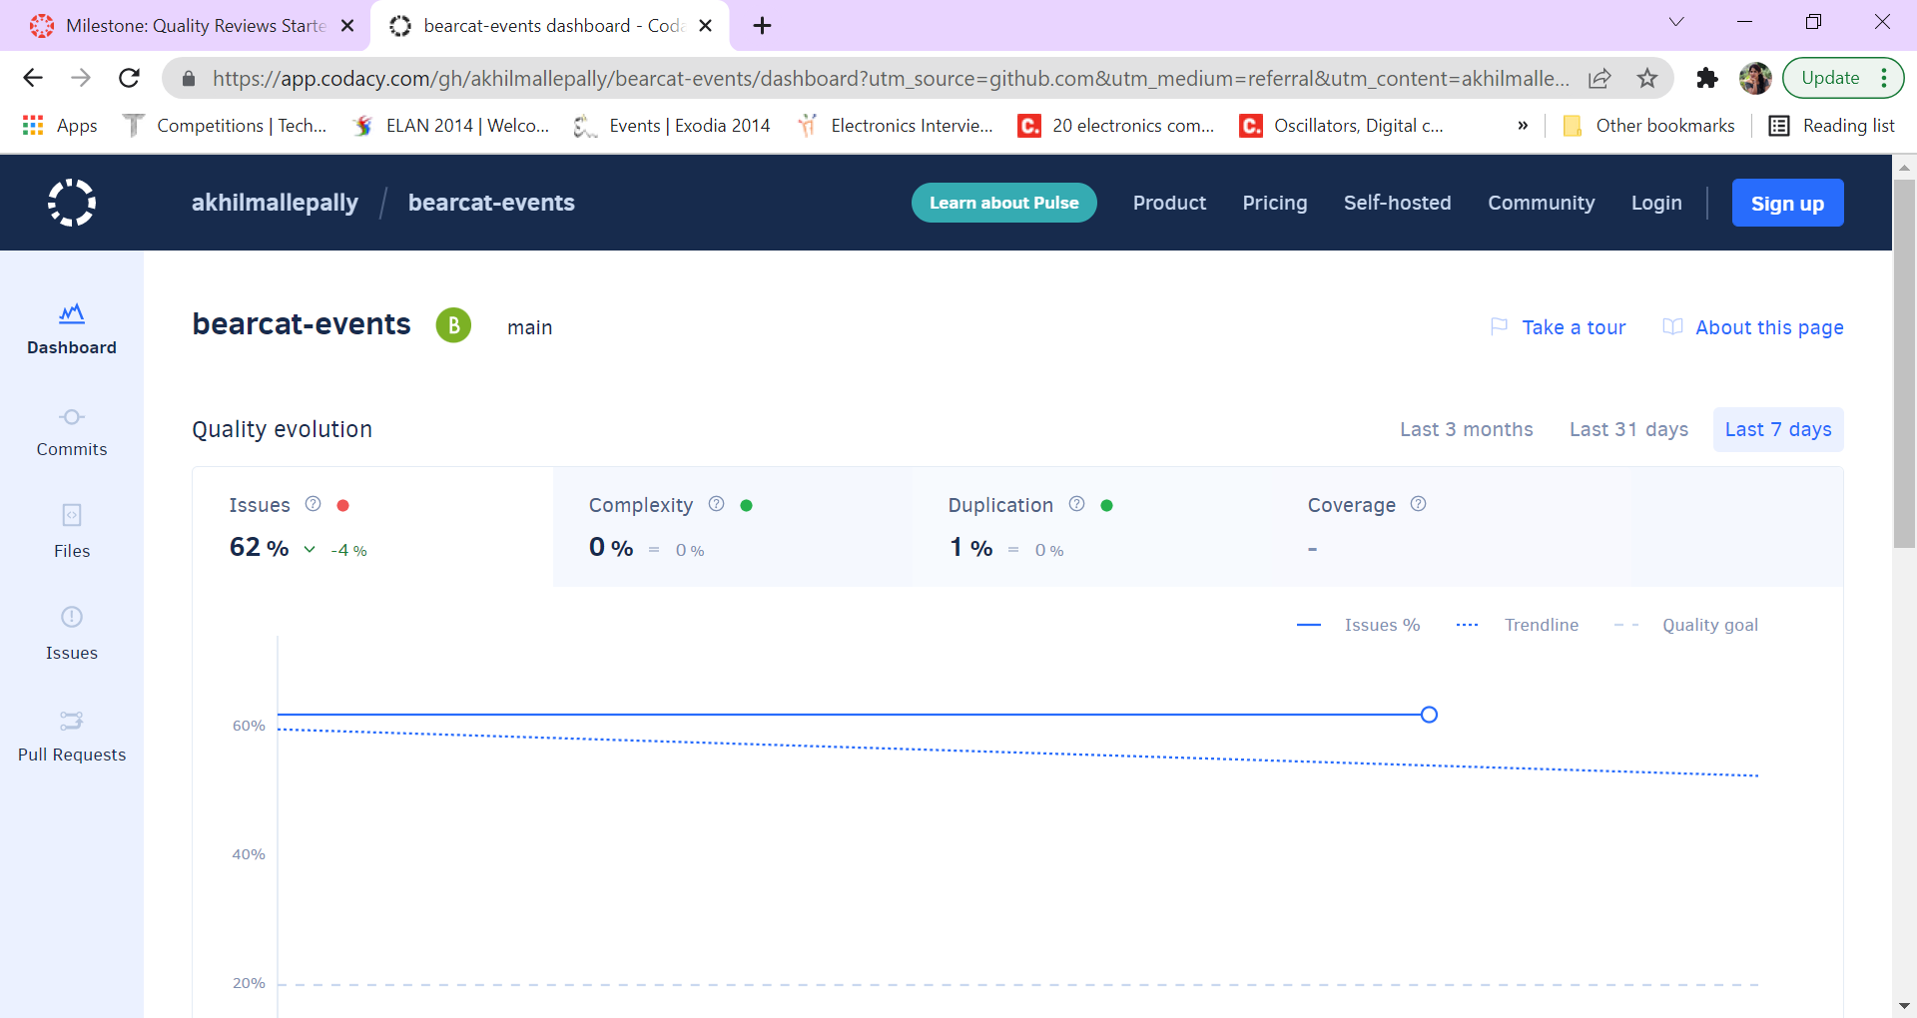

10. Check if they have swagger

**Good job with the swagger implementation.**

<https://bearcateve.herokuapp.com/swagger/>

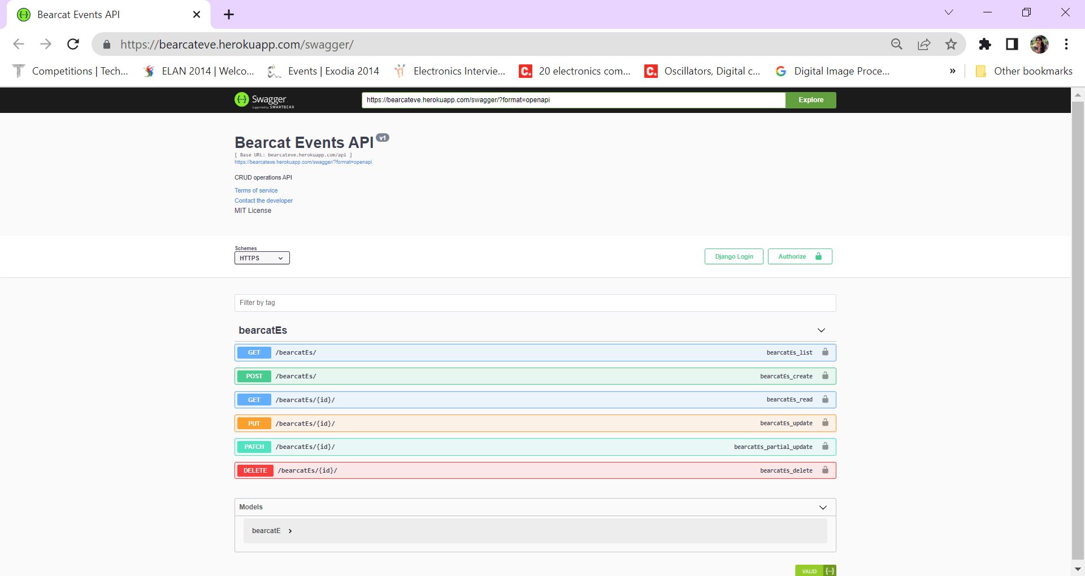

11. Check for the use of wiki

**Wiki is well-used.**

<https://github.com/akhilmallepally/bearcat-events/wiki/>

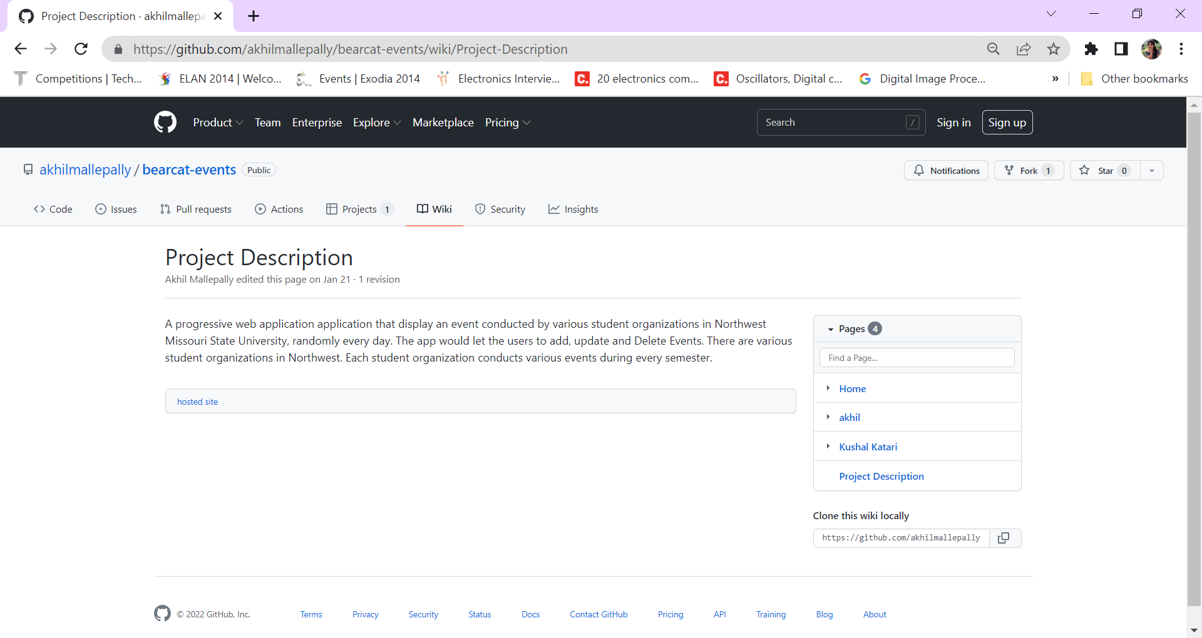

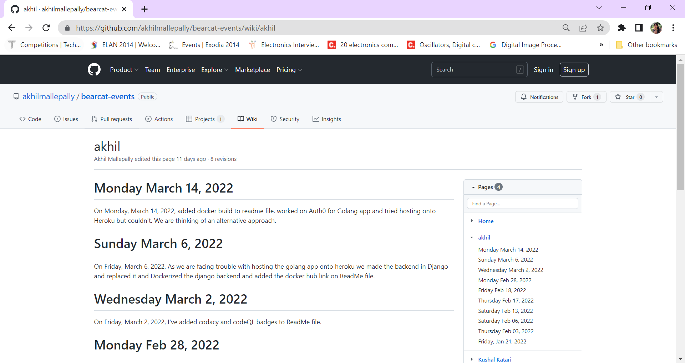

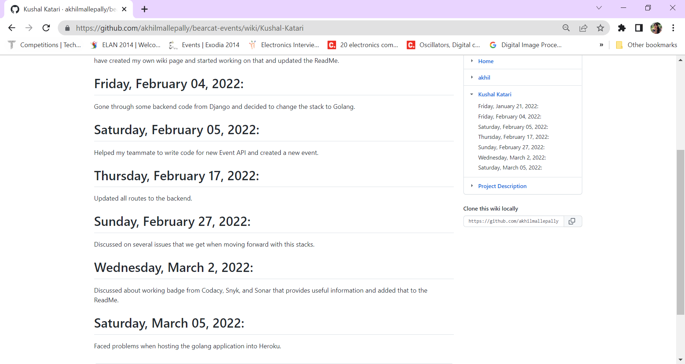

12. Check for GitHubActions Implementation

**On the github actions, you've done a fantastic job.**

<https://github.com/akhilmallepally/bearcat-events/blob/main/.github/workflows/codeql-analysis.yml>

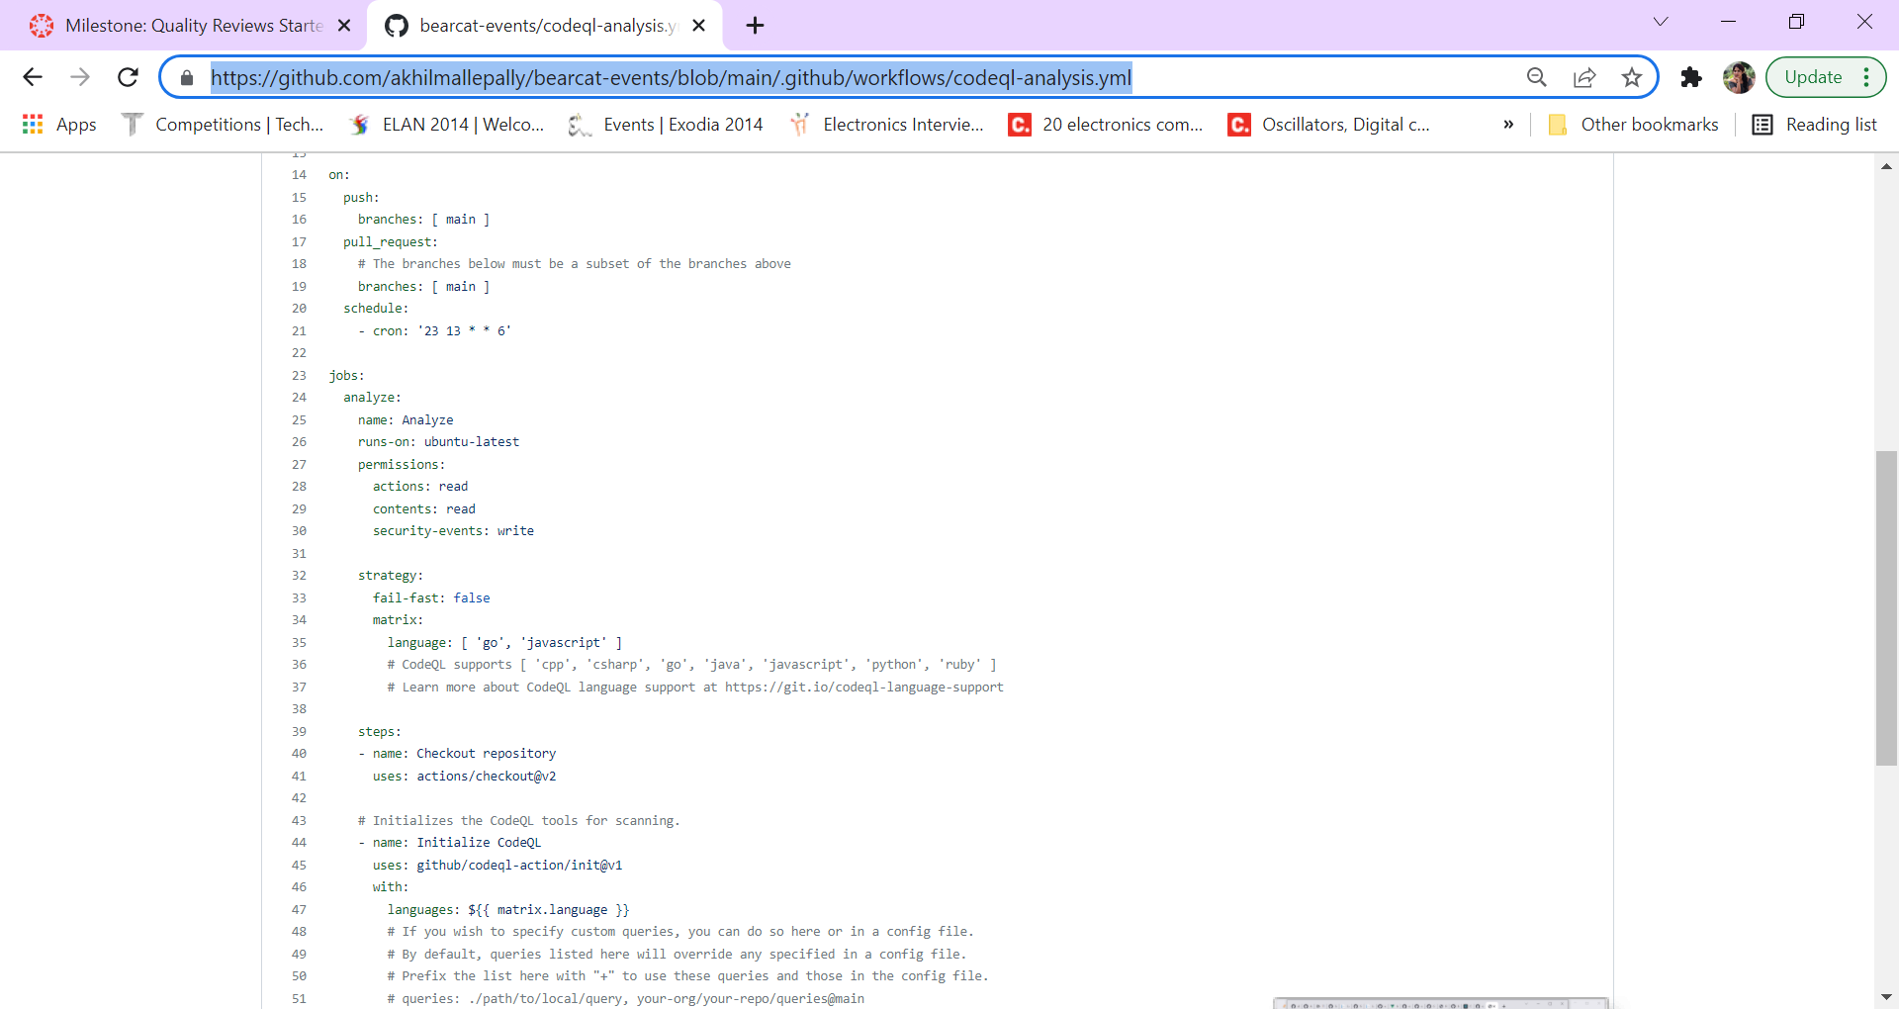

**Shiva Ram Kothapally**:

1. Check the code coverage of the app

* **They have used python coverage tool.**
* **They had good code coverage I am able to see the issues,complexity, Duplication.**

<https://app.codacy.com/gh/akhilmallepally/bearcat-events/dashboard?utm_source=github.com&utm_medium=referral&utm_content=akhilmallepally/bearcat-events&utm_campaign=Badge_Grade>

1. Check for team members details

* 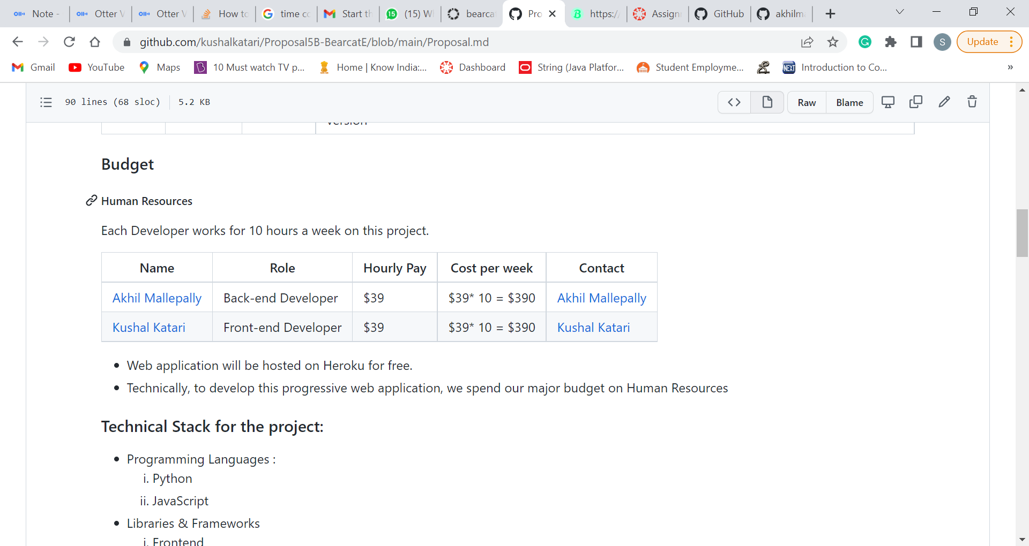

1. Check for the commits

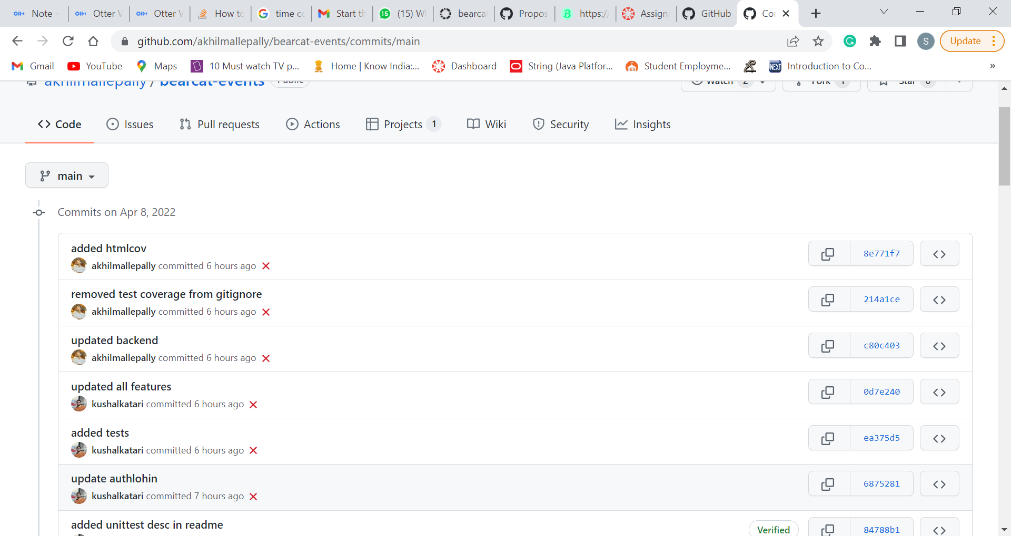

1. Check for the screen sketches

**Sketches are available on proposal repo**

